Receiver operating characterizes and Area under curve are helps to find the best classifier algorithm to build classification model.
Here we will find a value called threshold, that helps to increase, decrease the true positive and false positive values.
A threshold is the center value for classification problem
EX: In binary classification problem we predict labels as 0 and 1, we will conclude if the value is less than threshold then the person has no diabetes, if a value is greater than threshold then the person has no diabetes. That is what describes in below image, We will increase or decrease the threshold value to get good prediction
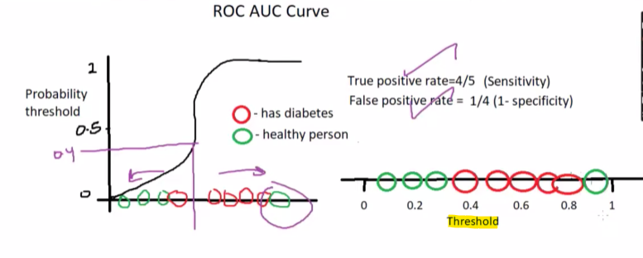
With ROC curve we will find confusion Metrix for this each threshold, the curved line are called ROC curve and the space under the curved line are called ROC, In Roc curve we will pot the True positive rate on y axis and False positive(wrong predictions) on x axis.
NOTE: Higher ROC value will has the good model prediction rate.
Following image the example of both ROC and AUC, we saw the performance of three classification model in this image. In this way we can find the best classification model, on the below image random forest classifier has the good prediction.
